**How to install Kinect SDK**

Go to: <https://www.microsoft.com/en-us/download/details.aspx?id=44561>

Click “Download”

Follow installation instructions.

**How to open the Unity file**

Copy the ZIP file to your hard drive.

Unzip the file and save it to the location you want.

Open Unity Hub, select Open, and go to the file location.

**How to change wall depth**

Click PR_MeasureDepth.

In the inspector tab, looking at the Measure Depth script the M Wall Depth determines how far the Kinect detects. The higher the number, the farther the distance.

**How to change the fish for the flocking**

Click on the FlockManager you want to edit.

In the inspector tab, looking at the Flock Manager script, the Fish Prefab controls what fish it controls.

Drag a fish prefab to the Fish Prefab to change the fish.

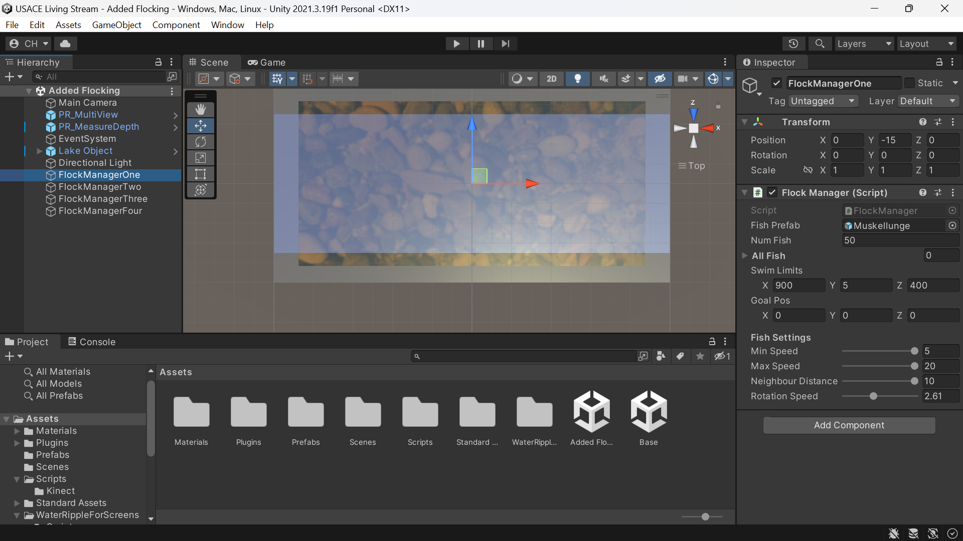

**Additional Resources**

<https://www.youtube.com/playlist?list=PLmc6GPFDyfw_Pouy2uRxVrEWFj4N1UOOp>

**Additional Questions**

Either send me and email at: [Charlesccharris@gmail.com](mailto:Charlesccharris@gmail.com)

Or add me on Discord: Charles Harris#8322